

GCLT – the Board of Trustees

The Gillingham Community and Leisure Trust Ltd. (GCLT) is a community-owned business and registered charity which runs on a ‘not for profit’ basis, operating leisure facilities to benefit Gillingham and the surrounding area.

The Board of Trustees
The Board of trustees of GCLT are responsible for the strategic direction and commercial viability of the business. All trustees are volunteers and unpaid. The role of the Board is to provide critical oversight and support to the General Manager and his leadership team; the Board carries the ultimate responsibility for the strategic direction, staff team, assets, activities and reputation of GCLT.

The GCLT Board support the General Manager and his leadership team in promoting an inclusive culture which views high professional standards as non-negotiable, seeking to provide i) a high quality and enjoyable experience for our customers, ii) appropriate opportunities for staff training and professional development, ii) a safe working environment, iv) the best pay and working conditions that the organisation can afford (with protection from inappropriate or bullying behaviour from colleagues and customers).

As a corporate body, we work hard to secure the future of the organisation in a sustainable manner, using the sum of our individual experience and expertise. In this way, we expect GCLT to continue to make a unique and valuable contribution to the local community for years to come. We recognise that, as a Board of trustees, we are stewards of an important legacy.

Phil Silvester CBE – Chair
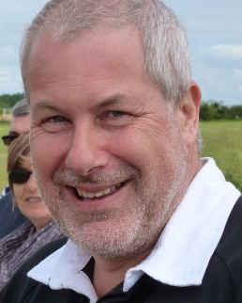
Phil joined the GCLT Board in August 2022. He is a retired Head teacher and International Education Consultant. In 2008, Phil was awarded a CBE by HM the Queen for his services to SEND regionally and nationally. After managing the expansion of Dorset’s largest special school, Westfield Arts College in Weymouth for 16 years (including building a £6M sports hall with a climbing wall and gym), Phil emigrated to France where he and his wife established a successful tourism business 2008-18). Since 2000, Phil has worked extensively in the UK and abroad as an education consultant, training inspectors and headteachers, school governors and trustees. He has worked with several national charities.
Phil is looking forward to using his leadership, organisational and commercial expertise to support the continued development of RiversMeet. Since 2018, Phil has been a regular gym user and Glyn (his wife) a regular pilates and fitness class user at RiversMeet. Outside of RiversMeet, Phil enjoys his four grand-children and appreciates foreign travel with his wife and dog (Mya – a black lab). His three children live in Dorset and Devon.

Simon Ward – Vice Chair
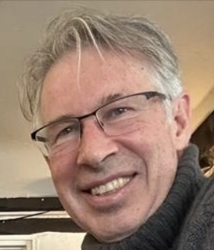
Simon Ward joined the GCLT Board in April 2023. Simon moved to Gillingham from Surrey at the end of 2022 and is an active user of the RiversMeet gym and regularly attends spin class on Saturday.
Simon has an extensive background in customer experience improvement and loyalty, having worked for large national organisations including BT, Centrica and Tesco.
In addition to his role with GCLT as Vice Chair, he is also a Director at Gillingham Town Football Club and regularly volunteers with Cranborne Chase - an AONB, leading walks and carrying out wildlife surveys in Wiltshire. Simon lives with his wife and daughter who has recently qualified as a lifeguard at RiversMeet.

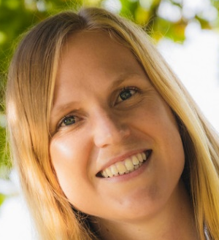
Laura Day
Laura became a GCLT trustee in January 2024. She is a Chartered Management Accountant and runs her own business supporting small to medium companies. Laura lives in Buckhorn Weston; she has always been a local resident. Sport and exercise have always been a central part of her life. Laura enjoyed swimming lessons and learnt to swim in the RiversMeet building long before it became RiversMeet! She has recently got involved in triathlon, meaning Laura spends lots of time on the roads either running or on the bike, as well as plenty of time swimming in the pool or in open water.
Laura is the treasurer of Wincanton Town Ladies Football Club. She also has the role of double checking the accounts for the Wincanton Wheelers Cycle club. A ‘Pets as Therapy’ volunteer, Laura enjoys taking her spaniel Alfie into different care homes each week.


Simon Chase
Simon became a GCLT trustee in April 2025. Simon went to Gillingham School and even swam in the open-air pool before what is now RiversMeet was built over it! He became assistant to the Pastor of a large Baptist church in Reading and subsequently Pastor of an inner London church for 7 years. In 1994, Simon and his family moved back to Gillingham. Simon is a Gillingham Town Councillor. For 19 years, he worked in various non-clinical, management roles within the NHS at Yeovil District Hospital. Simon has pastored Gillingham Baptist Church since 2015.

John Broadway
John became a GCLT trustee in December 2025. John sold his IT company and ‘retired’ to Dorset in 2025. John and his family live on Gillingham’s outskirts. John, his wife and children have a long association with Riversmeet and use the leisure centre extensively each week. John brings strong commercial and IT expertise to the Board. The Board looks forward to benefitting from John’s extensive commercial and IT expertise.

Maxine Caldwell
Maxine became a GCLT trustee in January 2026. Maxine, her husband and children all use Riversmeet Leisure Centre extensively and live in Gillingham. They have a long association with our leisure centre. With an extensive career in commercial finance as a chartered accountant, Maxine is currently working as the HR and Finance Director of a large building company in Dorset. Maxine has also acted as the Chair of Governors at her children’s local primary school.


Ella-mai Robey
Ella-mai became a GCLT trustee in January 2026. Ella-mai regularly uses Riversmeet Leisure Centre and she has a rich background in the media and communications (having worked for the BBC as a producer). Ella-mai lives in a village just outside Gillingham. Ella-mai currently works as the Community Arts Officer for Wiltshire County Council. She is well-used to applying for grants (including Section 106 applications), leading on safeguarding policy, and promoting social inclusion.

Barbara Hurst
Barbara became a GCLT trustee in February 2026. Barbara Hurst is a retired Senior Lecturer and Head of Department with extensive experience in Higher Education. She is currently a trustee of our parent charity (the Three Rivers Partnership) as well as being a Gillingham Town Councillor. Barbara has previously acted as a school Governor at a local Primary School with responsibility for Health & Safety and Safeguarding.

